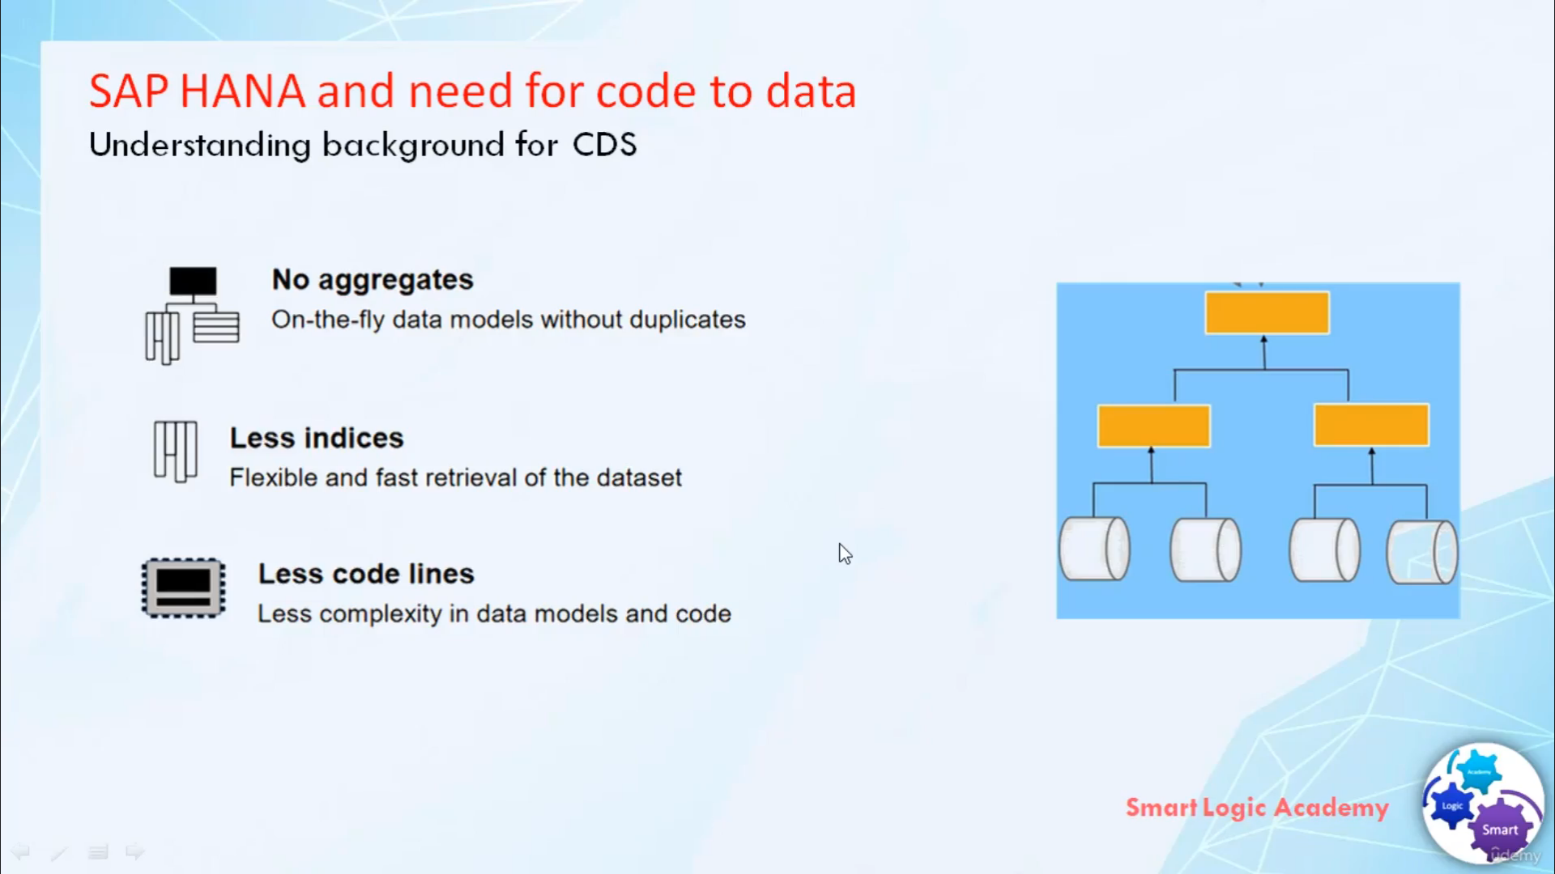

Hi and welcome back.

In this video, I will tell you some more features of SAP HANA. SAP HANA takes the

advantage of the latest technology development and change the ways of developing and executing the application

using the power of SAP HANA,

you can aggregate on the fly from any line item table. you do not need to prebuild aggregates. SAP HANA

can generate any view of the data at run-time all from the same source tables. SAP HANA

organize data using column stores which means that indexes are not needed.

They can still be created but offered little improvement.

By removing aggregates and indexes from the database, you are also removing a huge amount of application codes

that deals with the aggregate and the indexes. hence

as a result, you get a simplified code-data model as well as simplified application code. It also becomes

much easier to enhance the application and integrate additional functionality to the existing code.